Assignment:

Create a web application that displays trade data (front-end and back-end solution).

App communicates with own back-end solution. Fetches 10 stock tickers from polygon.io, then starts generating and streaming fake prices for them 10 times per second.

Application should display prices for these stocks and calculate change difference since last update:

1. Table component to display stock name and price.
2. Component should show stock price change since last update.

Front-end requirements:

1. React framework
2. Ability to fetch next or previous 10 stocks

Back-end requirements:

1. Streaming done with WebSockets
2. REST API that is connecting to external polygon.io to fetch list of stocks (specifying how many stock tickers per page you want to see)

Flow: UI Fetch 10 stocks from polygon.io via REST to back-end -> Create WebSocket connection for streaming prices of these stocks -> calculate change since last update and display prices in a table.

Idea mock-up (colors and display is up to the developer):



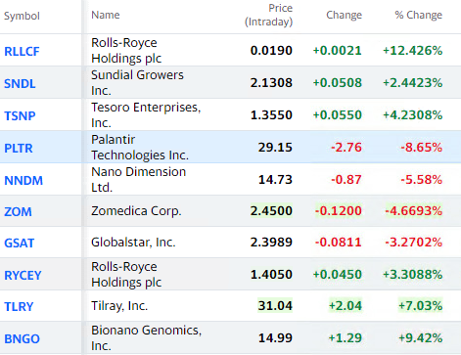

Ticker API:

* <https://polygon.io/docs/get_v2_reference_tickers_anchor>